**DIGITAL-NURTURE-4.0- JAVA FSE**

**WEEK-2 Junit Testing Basics**

**Exercise 1: Setting Up JUnit**

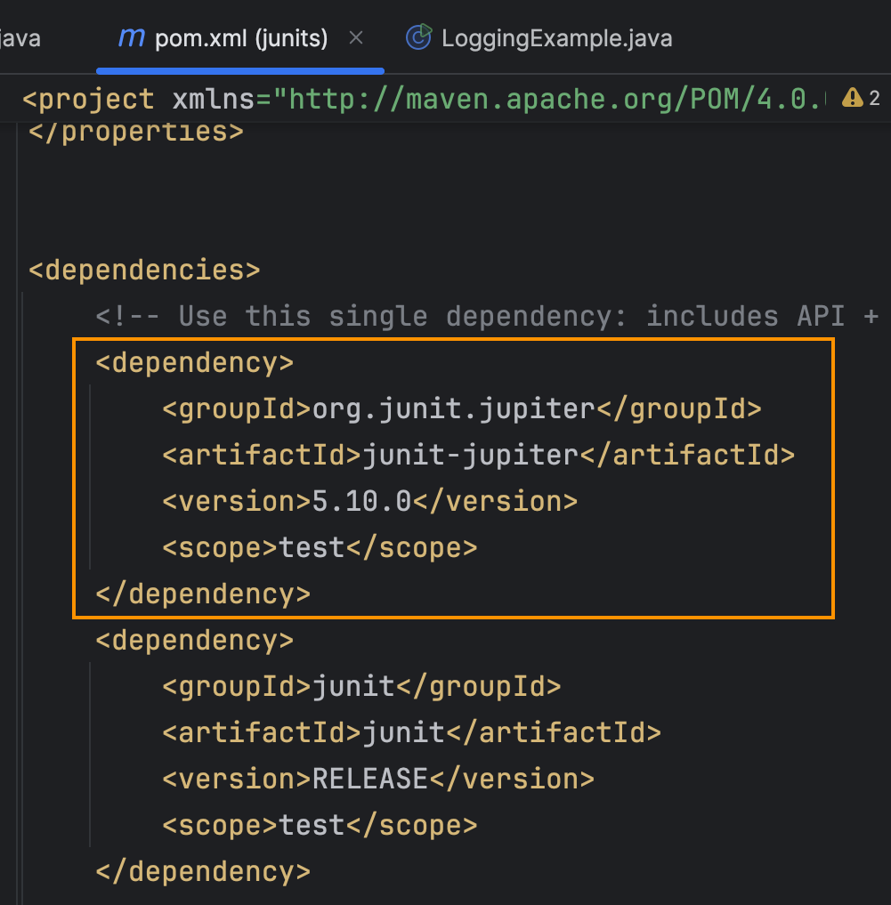

**Exercise 2: Writing Basic JUnit Tests**

**Calculator class** - It contains the functions to be tested

**CalculatorTest class -** It is the class which is used to test the functions present in

Calculator class.

**Scenerio 1 : when all test are passed**

***Calculator.java***

package net.javaguides;

public class Calculator {

    public int add(int a,int b){

        return a+b;

    }

    public int sub(int a ,int b){

        return a-b;

    }

    public int multiply(int a ,int b){

        return a*b;

    }

    public int divide(int a ,int b){

        return a/b;

    }

}

***CalculatorTest.java***

package net.javaguides;

import org.junit.jupiter.api.Test;

import static org.junit.jupiter.api.Assertions.*;

class CalculatorTest {

    @Test

   public void addTest(){

      Calculator calc=new Calculator();

      //add

      int res=calc.add(2,3);

*assertEquals*(5,res);

      //sub

        res=calc.sub(7,6);

*assertEquals*(1,res);

       //multiply

       res=calc.multiply(4,5);

*assertEquals*(20,res);

       //divide

       res=calc.divide(20,5);

*assertEquals*(4,res);

   }

}

***Output***

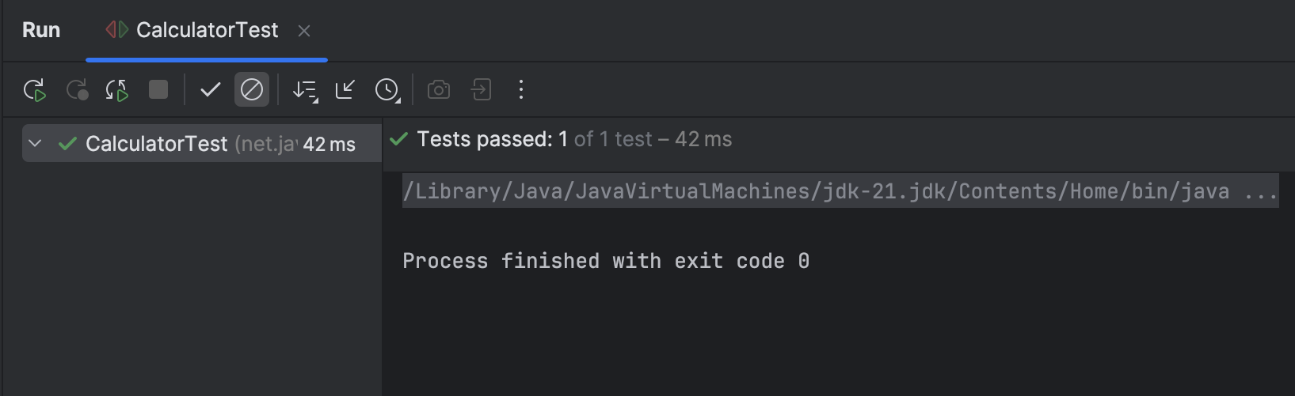

**Scenerio 2 : when test cases fails**

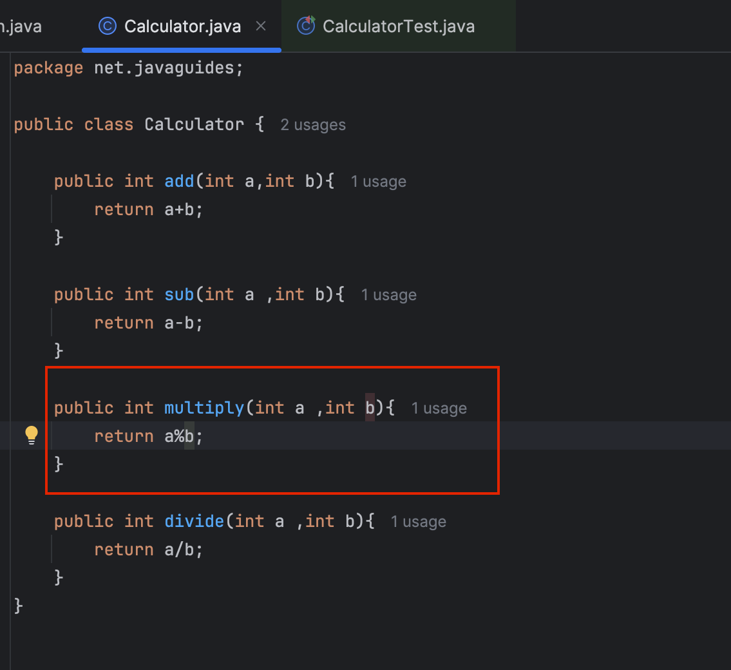

***OUTPUT:***

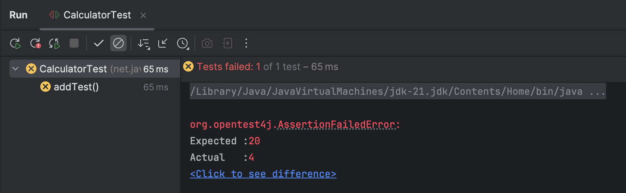

**Exercise 3: Assertions in JUnit**

***TestAssertions.java***

import org.junit.jupiter.api.Test;

import static org.junit.jupiter.api.Assertions.*;

public class TestAssertions {

    @Test

public void testAssertions() {

**// assertEquals**

        String greeting = "Hello, " + "World!";

*assertEquals*("Hello, World!", greeting);

**// assertTrue**

        int[] nums = {1, 2, 3};

        boolean containsTwo = false;

        for (int num : nums) {

            if (num == 2) {

                containsTwo = true;

                break;

            }

        }

*assertTrue*(containsTwo);

**//assertFalse**

        String str = "JUnit";

*assertFalse*(str.isEmpty());

**//assertNotNull**

        Person person = new Person("Swetha B");

*assertNotNull*(person);

    }

    static class Person {

        String name;

        public Person(String name) {

            this.name = name;

        }

    }

}

***output***

